**EXPERIMENT - 2**

**AIM OF THE EXPERIMENT:**

To design and verify Inverting Amplifier using multisim

**APPARATUS REQUIRED:**

PC loaded with multisim software

**THEORY:**

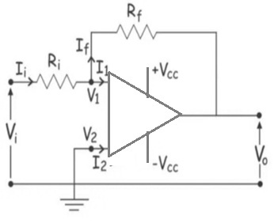An inverting op-amp is a type of operational amplifier circuit used to generate an output that is out of phase as compared to its input through 180 degrees which means, if the input signal is positive (+), then the output signal will be opposite. The inverting op-amp is designed through an op-amp with two resistors.

**Vout = – (Rf/Ri) x Vin**

Inverting Op Amp Gain**(Av) = – (Rf/Ri)**

**VERIFICATION:**

Circuit Diagram

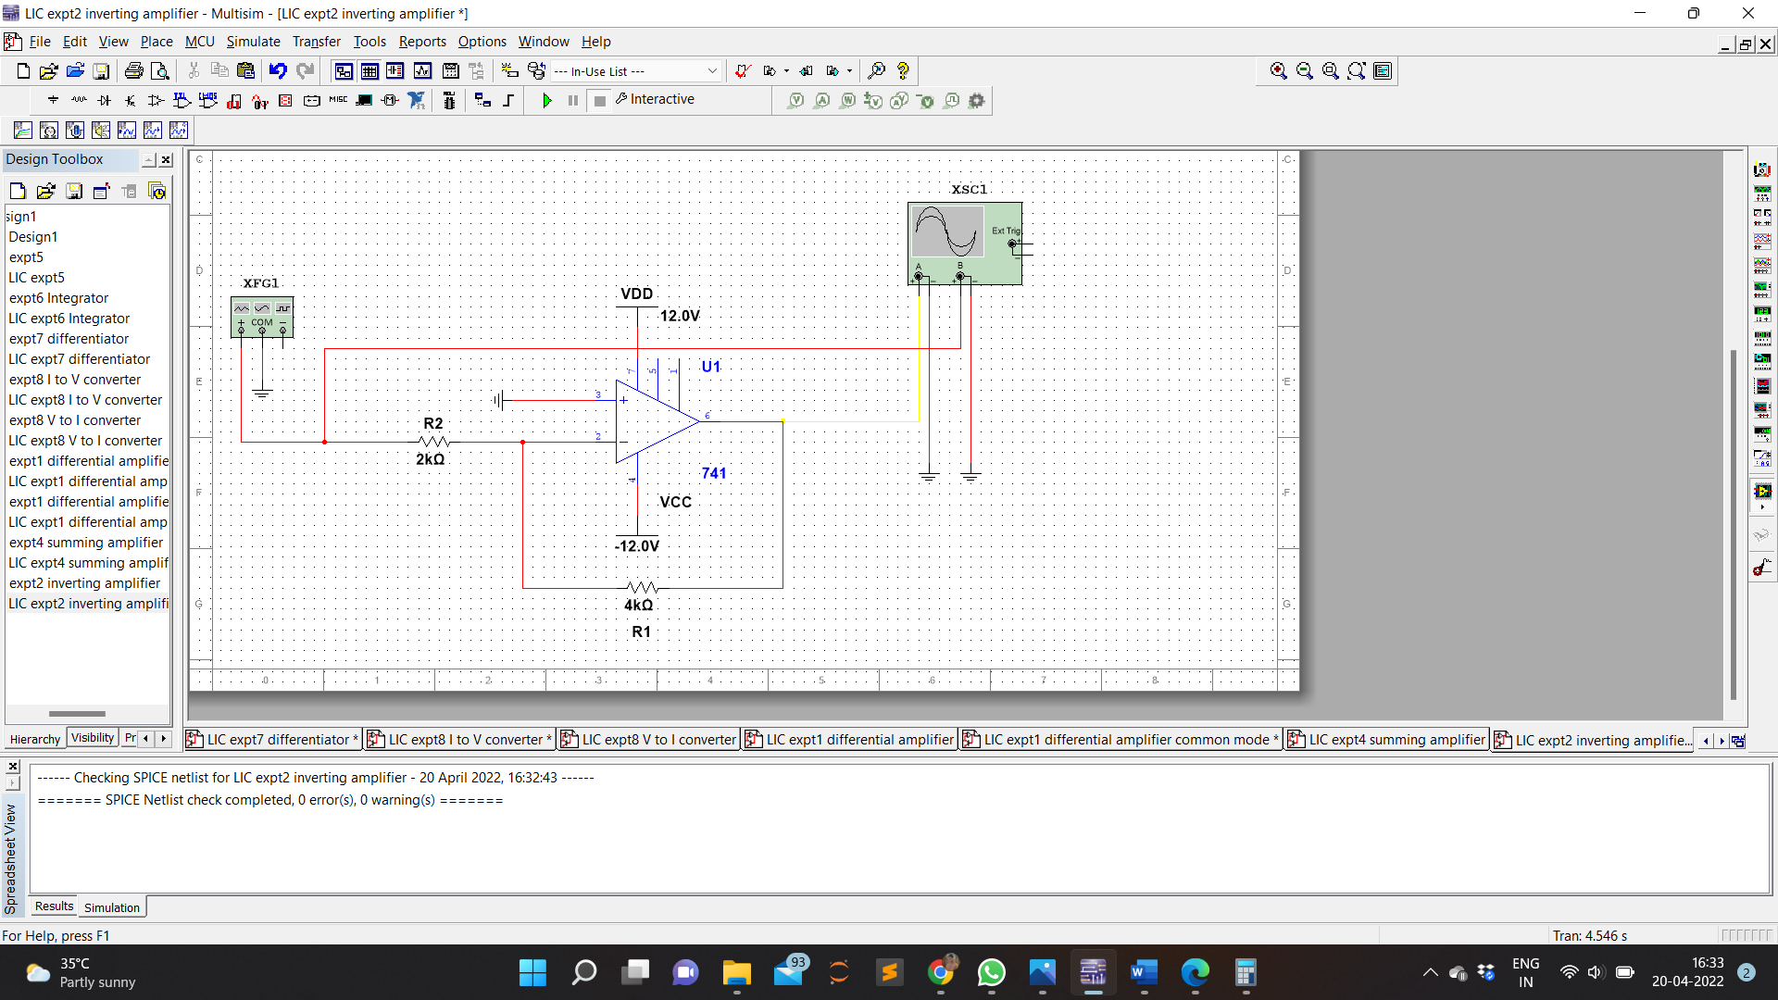

Waveform

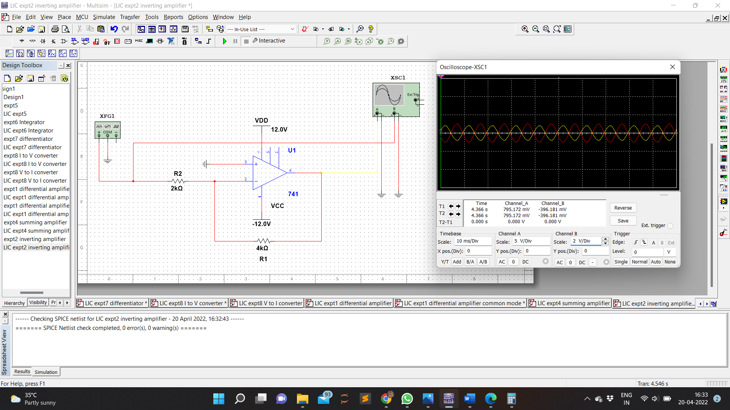

Calculation

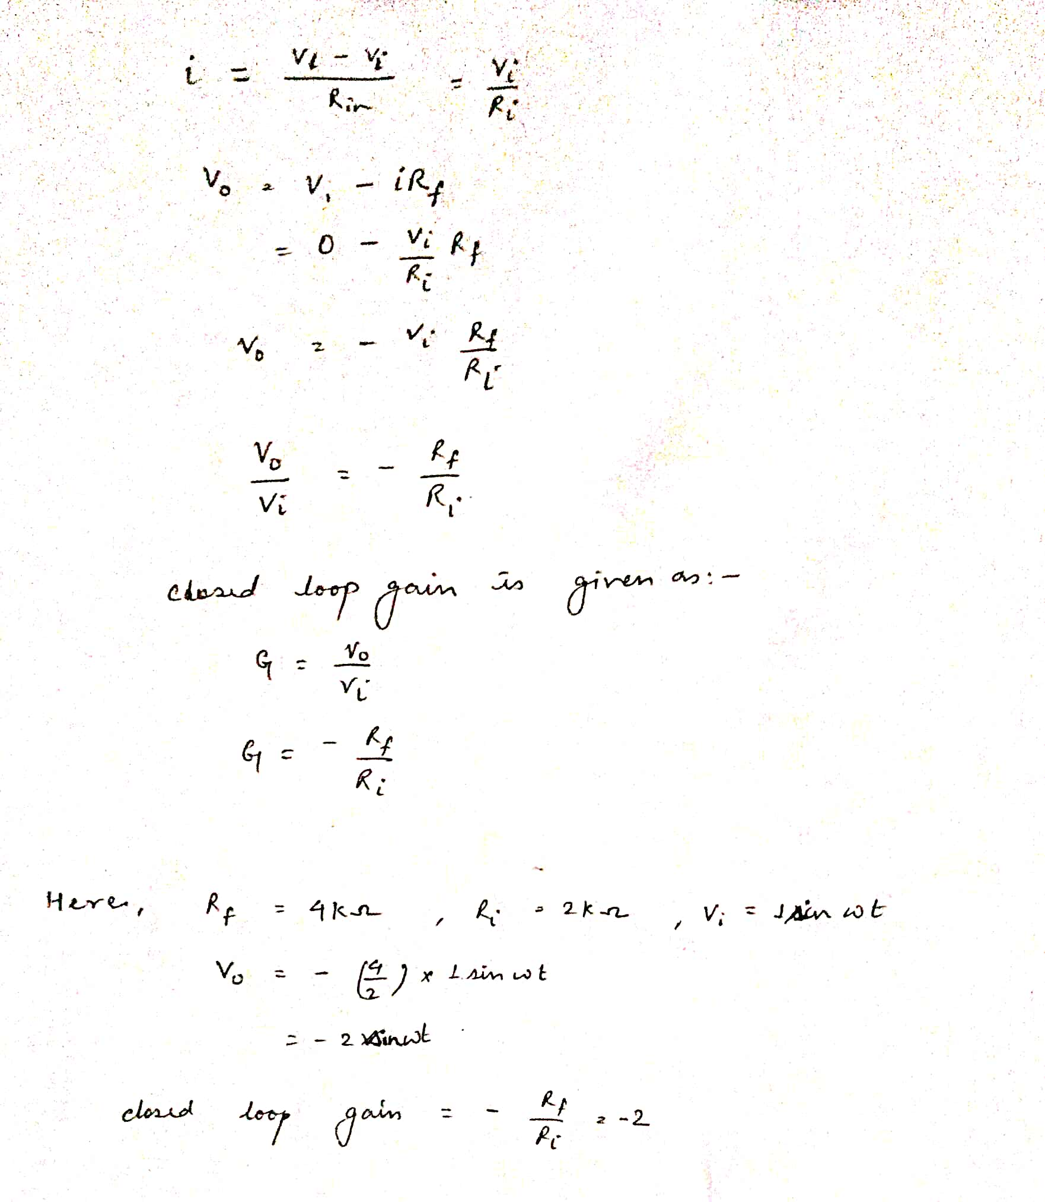

**RESULT:**

Inverting operational amplifier was designed using multisim , simulated and verified